Chapter 7, Solution 52.

Using Fig. 7.118, design a problem to help other students to better understand the step response of an RL circuit.

Although there are many ways to work this problem, this is an example based on the same kind of problem asked in the third edition.

Problem

For the circuit in Fig. 7.118, find i(t) for t > 0.

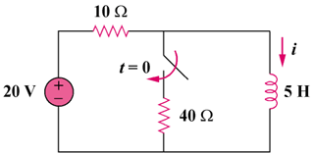

Figure 7.118

Solution
 